03 December 2019 – Status Document
Updates on SyncTrazor and Git.
Schema Design
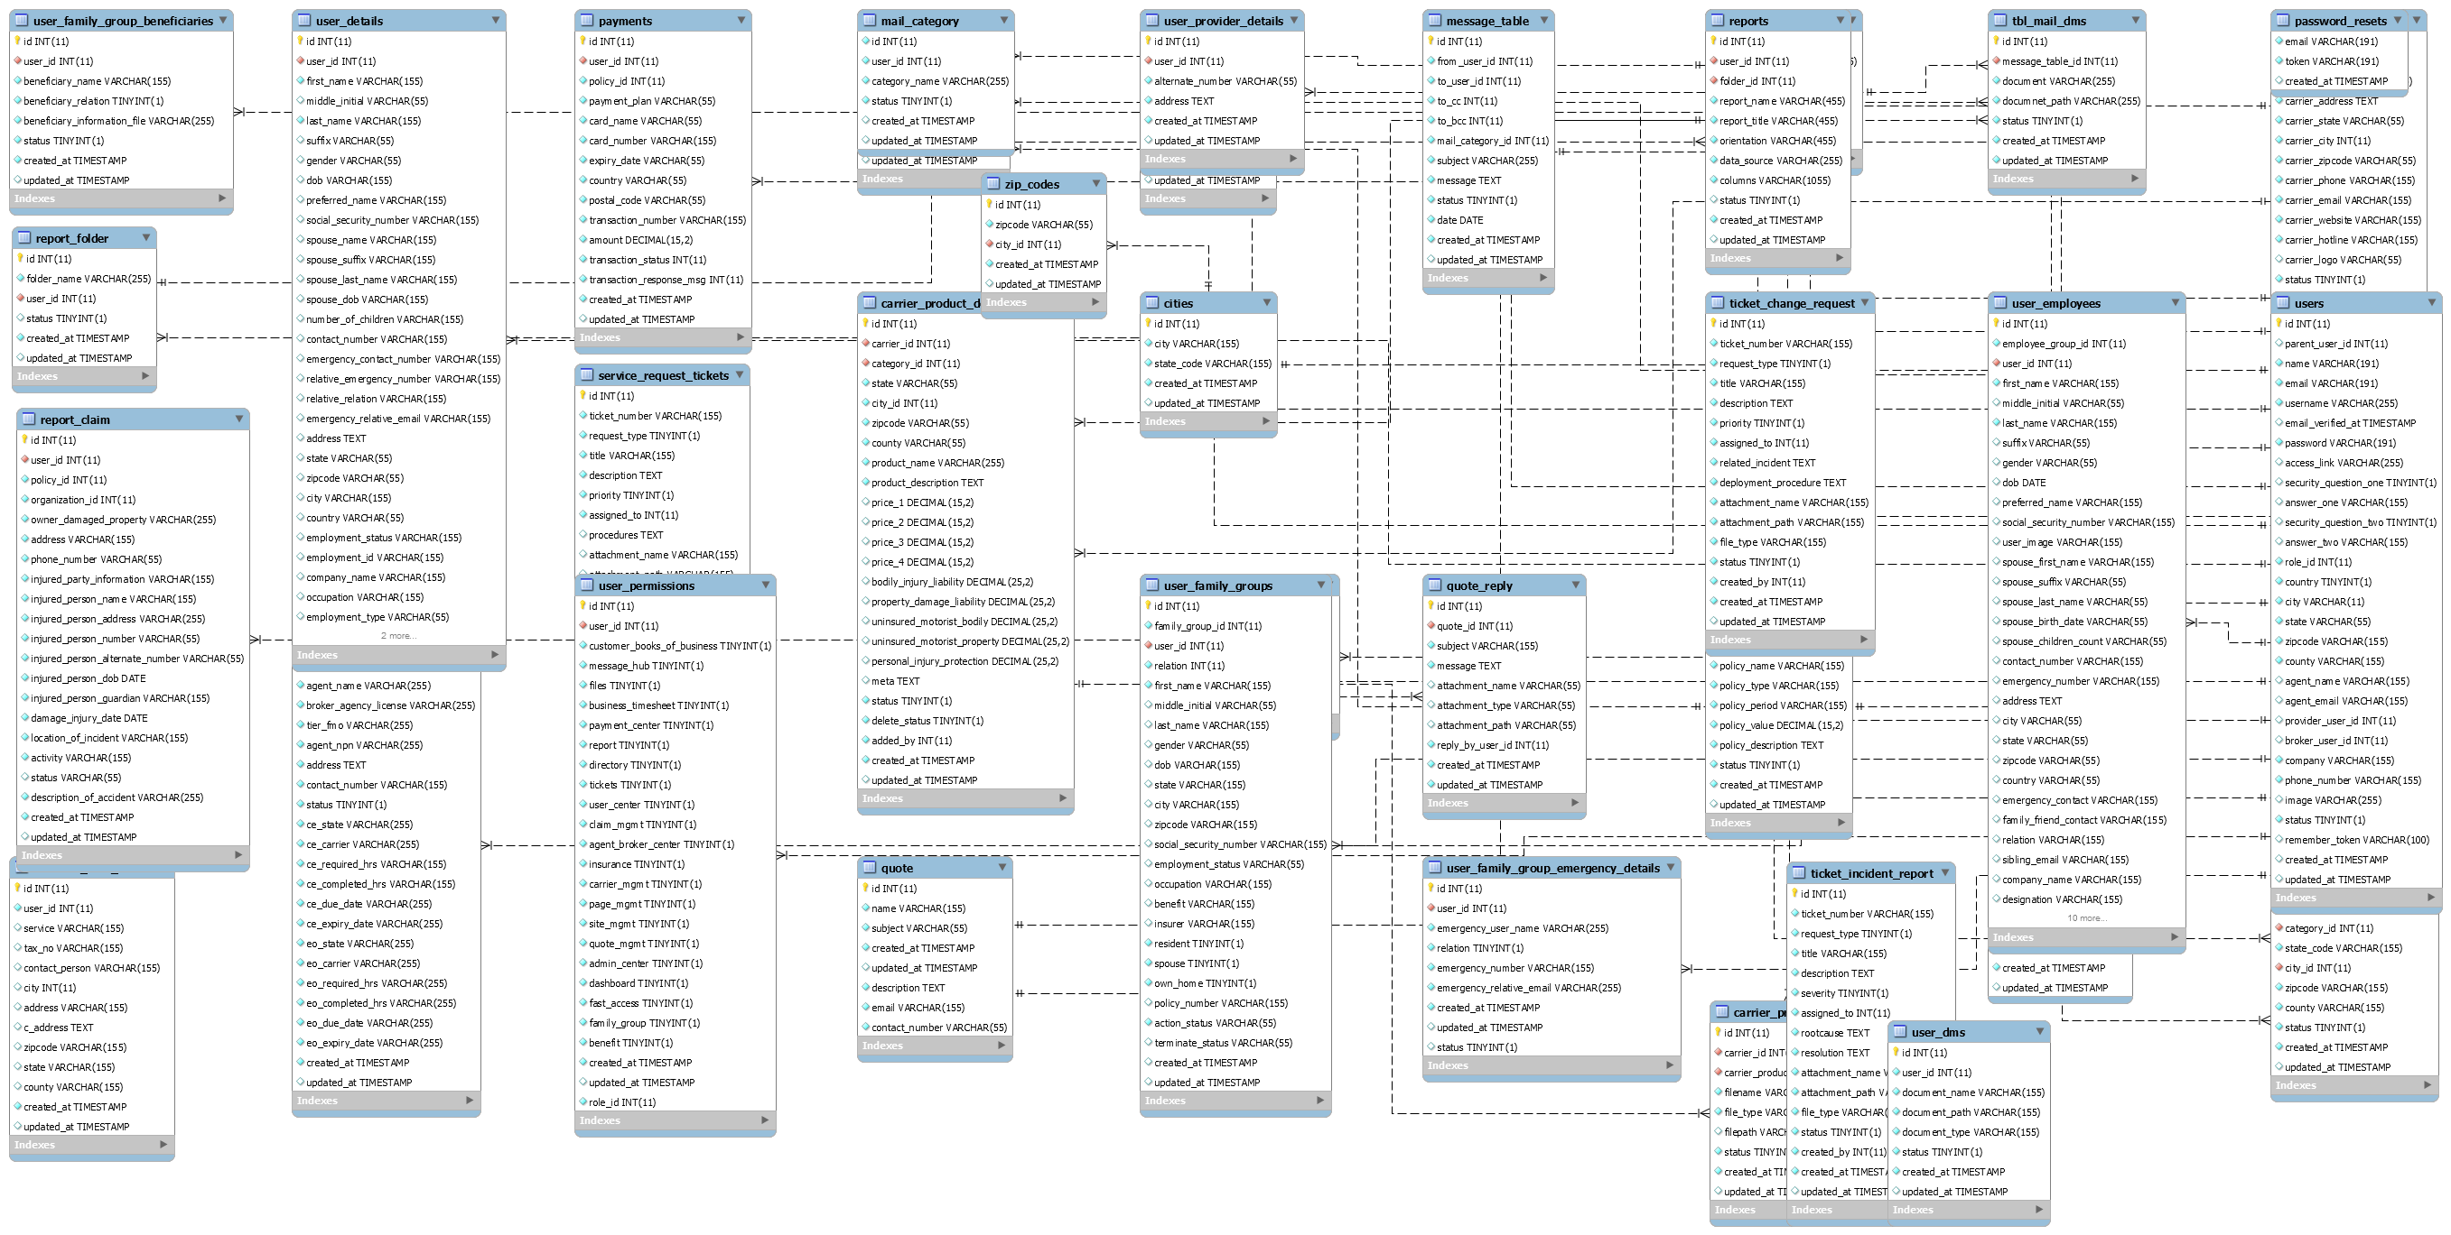

Modules / Sections Worked On
Customer Profile:
Module Customer Profile - Create new Customer Section

Database Schema Design with new updated tables / columns and uploaded both on file.cubeduty and git
Meeting with Josh analysis of Project
Tasks Listing to be covered in next 2 days..
Section --- Basic Info update as per new HTML and test in mobile view
Gender, change dropdown to radio select
Add datepicker for Date of Birth
Section --- Emergency Contact
Design Change (Form) In Progress

Section --- Access to Dashboard - New Design Change (Form) new permission still need to done and saving in DB pending
Section --- Access to Products - Design Change (Form)
Section --- Detailed Information - Design Change (Form)
Section --- Emergency Contact - Design Change (Form)
Section --- Authentication - Design Change (Form)
Section --- Documents - Desgn Change (Form)
Section --- Agent In Charge - Desgn Change (Form) & Create the dropdown for broker agent as example -- Agent 1 / agent1 @ gmail.com
Section --- Search - Design Update
Search Result shown list as per mockup, on the basis of mentioned fields with HTML loading of records
Customer Profile - Create New Customer Modue completed except the Access to Dashboard Saving into database and did Unit Testing on server - Admin_Customer_3.1

DB schema design for updated tables/column for Access to Dashoard & Family/Group Info section
Section --- Access to Dashboard - data saved in DB as per Wireframe instruction
Section --- Family/Group Information - HTML Design implementation
Section --- Family/Group Information - data saved to DB
Section --- Family/Group Information - created script for datapicker for each Date of Birth fields.
Testing On Server

Section --- Product Selection - HTML Design Implemetation
Section --- Insurance Options - HTML Design Implementation
Section --- Insurance Options - HTML Design for Insurance Compare Popup
Section --- Product Selection - Listing of product on basis of location & access to product by Ajax Call --- In progress
Section --- Insurance Options - List the available insurance options based on Product Selection by Ajax Call --- In progress
Section --- Insurance Options - Create script to open popup window when click on compare.
Section --- Insurance Options - Create script to compare multiple insurance at once by Ajax Call --- In progress
Section --- Insurance Options - Reset button for compare.
Testing On Server

DB schema design for updated tables/column for Insurance Options
Section --- Product Selection & Access To Product - Change heading from Product Selection to Product Category Selection & Access to Product to Access to Product Category.
Section --- Product Category Selection - Listing of product on basis of location & access to product by Ajax Call
Section --- Access To Dashboard - Blade file modified for Product Category Selection to get some more data.
Section --- Insurance Options - List the available insurance options based on Product Category Selection by Ajax
Section --- Insurance Options - Blade file created to append the Insurance Options HTML by Ajax
Section --- Insurance Options - Create script to compare multiple insurance options
Section --- Insurance Options - Validation for minimum 2 & maximum 3 insurance options can be compared.
Testing On Server

Section --- Customer Benefit - HTML design implementation
Section --- Documents - HTML design implementation
Section --- Documents - Upload section re-positioned at bottom after list
Section --- Payment - HTML design implementation
Section --- Payment - Show payment section when insurance options continue button clicked.
Section --- Payment - Ajax call on button click
Section --- Payment - Create function to get policy data & create blade file.
Section --- Payment - Auto populate the policy data in payment form blade file. --- in progress
Section --- Payment - Save payment data when pay button clicked by Ajax call --- in progress
Section --- Payment - Create funciton to save payment data with ajax call --- in progress
Testing On server

Section --- Basic info customer - Loader on Input fields
Loader for City field on State change by Ajax Call
Loader for Zipcode field on City change by Ajax Call
Loader for County field on Zipcode change by Ajax Call
Section --- Insurance Options – Loader for insurance options div when Product Category Selection Change by Ajax Call
Section --- Insurance Options – Compare & Cancel button, show button when insurance options available otherwise hide the button
Directory Structure for View Files – Created Seperate blade files for Add, Edit & List Customer Section.
Directory Structure for View Files – Created Seperate blade files for each modules like profile, detailed info, emergency contact etc, to make these modules reusable in edit section.
Testing on local server for new directory structure & functionality

Customer Profile - Edit Customer Section
Loader for Edit Section on Ajax Call when Edit Button clicked.
Custom popup replaced with Bootstrap Alert Popup design for Error message, when Edit Button clicked without selecting a user.
Section --- Customer Profile – HTML design fixing
Common blade file used for Add & Edit
Collapse when down icon click
Input Field align according to the new design.
Profile Image section & button
Section --- Customer Profile – Populating data in customer profile form
Section --- Customer Profile - Loader on input fields
Loader for City field on State change by Ajax Call
Loader for Zipcode field on City change by Ajax Call
Loader for County field on Zipcode change by Ajax Call
Section --- Access to Dashboard - Checkbox design for permission input fields
Section --- Access to Dashboard - Get the permission data from DB
Section --- Access to Dashboard - Displaying the checked & unchecked permission checkbox.
Section --- Access to Dashboard - Saving permission data on update
Section --- Access to Products - New checkbox design and showing the checked & unchecked data.
Testing on live server for functionality & directory structure.

Section --- Detailed Information – HTML Design fix
Input fields align
Collapse when down icon click
Section --- Detailed Information – Input fields change for Gender from dropdown to radio.
Radio design change for permanent regident field.
Radio design change for spouse or segnificant other.
Radio design change for own or rent home field.
Section --- Detailed Information – Datepicker for input fields date of birth
Section --- Detailed Information - Populate data for detailed information.
Section --- Emergency Contact - HTML Design fix
Input fields align
Collapse when down icoon click
Section --- Emergency Contact - Populate data
Showing each saved emergency contact.
Add & Remove functionality to Add or remove the Emergency Conatct.
Section --- Authentication – HTML design fix
Input fileds align
Cpllapse when down icno click
Checkbox design change for Temporary Access link
Section --- Authentication – Populate data
Testing on Server

Section --- Family Group Information --- New HTML implementation
Section --- Family Group Information --- Create Script to Add & Remove Family Group Info Div
Section --- Family Group Information --- Get the list of saved Family Group info data from DB.
Section --- Family Group Information --- Populate family group data for all saved family group.
Section --- Family Group Information --- Create logic to update existing family group data.
Section --- Family Group information --- Create logic to remove the existing family group data & add new family group data.
Section --- Product Category Selection – New HTML implemetation
Section --- Product Category Selection – Listing of product on basis of location & when access to product checkbox checked.
Testing on server
Team Meeting

Customer Profile - Add Customer Section
Load Add form By Ajax Call when Add button clicked
Replaced Save & Cancel button from bottom to above section Product category selection
Section --- Insurance Options - When continue button clicked show an alert message 'Please save the form first'.
When form saved redirect to edit section and open the edit profile of the saved customer.
Customer Profile - Edit Customer Section
Section --- Product Category Selection – Pre populating listing of products on basis of location & access to product
Section --- Insurance Options - List the available insurance options based on Product Selection by Ajax Call
Section --- Insurance Options - Compare multiple insurance at once.
Section --- Insurance Options - Validation for minimum 2 & maximum 3 insurance options can be compared.
Section --- Payment - scroll to payment form when continue button clicked
Section --- Payment - save the payment form data with ajax call and show the success message
Testing on server
Logic for Payment - Customer Profile – Add Customer Section
Customer Benefit, Agent In charge, Payment, Document section will move to edit section.
Steps for logic
1 – After clicking the continue button of the insurance options, an alert box will be open with message Please save the form first to continue. form will scroll up to the save button.
2 – After the form saved, redirect to the Edit Customer Section with pre-populated data for that customer profile.
3 – Then compare the insurance options and click continue button. Payment form will be open for payment.
4 – Add Payment information, Customer benefits, Agent in-charge & document, then update the form.
family group

Customer Profile - Edit Customer Section
Section --- Payment - Listing of the payment
Section --- Payment - Show more button for listing
Section --- Payment - Update listing on ajax call when show more button clicked.
Section --- Payment - Edit & Cancel button action & functionality
Section --- Payment - After saving the data of payment save policy information.
Section --- Customer Benefit - New HTML implementation.
New fields Name, Beneficiaries.
Section --- Customer Benefit - Save customer benefit info.
Section --- Agent in charge - New HTML implementation.
Combine Name & Email fields.
Show Name/Email fields data on basis of broker by ajax call on change of broker.
Loader on Name/Email field on change of broker by ajax call
Section --- Agent in charge - Populate data for saved info.
Customer Profile - Add/Edit Customer Section
Section --- Family/Group Info - Add new fields Email, Employer Name, Employer Phone
Section --- Family/Group Info - Populate the info on basis of email by ajax call
Section --- Family/Group Info - Update the DB schema for newly Added fields.
Section --- Family/Group Info - Save/Update the data.
Testing On Server

Database Alters:
No Changes

